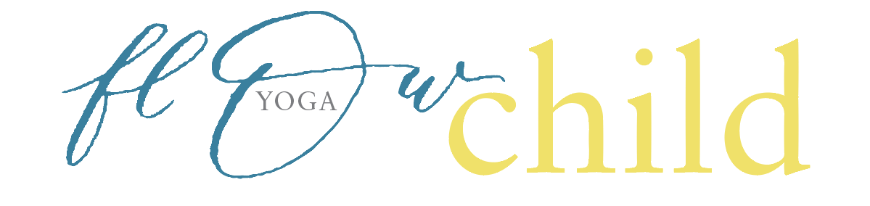
Application Form Flow Child Yoga – A 50hr certified Children’s Yoga Teacher Training
Full Name…………………………………………………………………………………
Address………………………………………………………………………………………
Country………………………………………………………………………………………
Phone number/mobile………………………………………………………………………
Date of Birth…………………………………………………………………………………
I wish to register for the

Geelong Course July 16-18th 2021 Children’s Yoga Teacher training
Why do you want to do this course?
…………………………………………………………………………………………………………………

What relevant qualifications do you have?
............................................................................................................................................................

What experience do you have with Yoga?
…………………………………………………………………………………………………………………

What experience do you have working with Children?
…………………………………………………………………………………………………………………

Cost $1200 due in full by June 30th 2021
If You need another extended plan please call Di

Signature and Date …………………………………………………………
Please Pay into account and email us this signed application to info@ebbandflowwellness.com.au
Ebb and Flow Wellness Studio BSB 013642 AC no. 224 820 032
please put surname and course for ref

